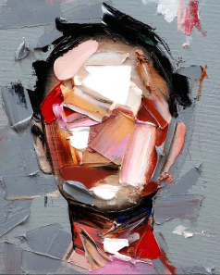**PINTURA**

<https://i.pinimg.com/564x/8f/0f/f7/8f0ff74e6d901f5c87e3530e8393605e.jpg>

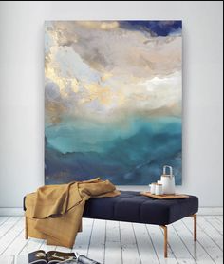

<https://i.pinimg.com/236x/55/88/48/5588482ab5ceb8b4f2ef27237320f7e1.jpg>

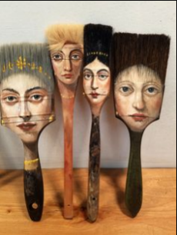

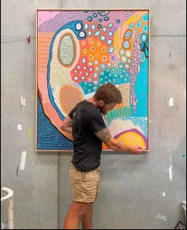<https://i.pinimg.com/236x/d5/e7/7b/d5e77b12afa88c732213e9f9d9ecfc77.jpg>

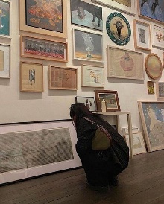<https://i.pinimg.com/236x/de/0a/c0/de0ac08505246ed97a9828c37d661fa4.jpg>

<https://i.pinimg.com/236x/ed/f4/b1/edf4b1824f7a3d61cefa8bf15f77e82a.jpg>

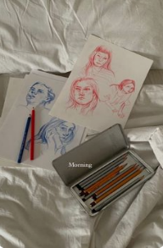

<https://i.pinimg.com/236x/24/fe/fc/24fefca96d49392d8bca00d4fdd3da8e.jpg>

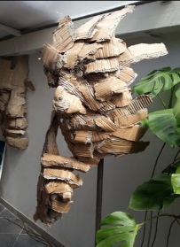ESCULTURA

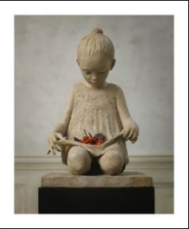<https://i.pinimg.com/236x/4e/24/0b/4e240bc4899d6831b1c64a68fb3bc6d2.jpg>

<https://i.pinimg.com/236x/8c/a4/65/8ca4652fc084cb10898d3a667b309666.jpg>

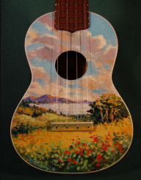MUSICA

<https://i.pinimg.com/736x/f3/4e/35/f34e35a5ff1e1eb7e6c1a51fb7f8ebd2.jpg>

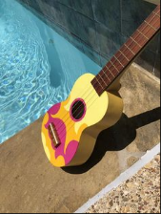

<https://i.pinimg.com/236x/fd/9b/22/fd9b22b395cd7ee3ec83447c9b9badd0.jpg>

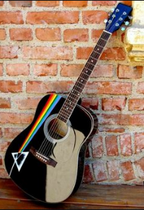

<https://i.pinimg.com/236x/c2/f9/e8/c2f9e87e0697e7f317c8de91c8de0278.jpg>

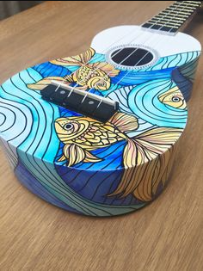

<https://i.pinimg.com/236x/f5/16/0f/f5160f91e0b23a04b4270e858fac2919.jpg>

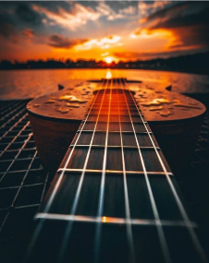

<https://i.pinimg.com/564x/f5/ee/34/f5ee3478113ba2627a5704b35c8f2096.jpg>

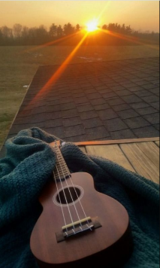

<https://i.pinimg.com/564x/c8/73/6c/c8736c12558d445777ebd6621aae88c0.jpg>

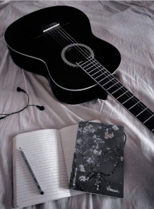

<https://i.pinimg.com/236x/5f/89/fc/5f89fc2282778e192058bf95d1370eaf.jpg>

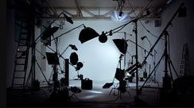

CINE

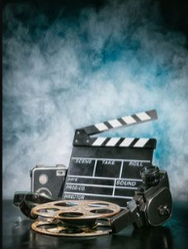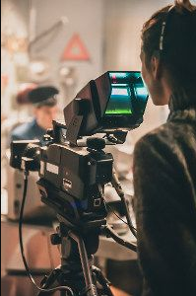<https://i.pinimg.com/236x/01/9f/58/019f58f3ff52227e0db2332f607a778a.jpg> <https://i.pinimg.com/236x/99/72/e5/9972e549461642766930cdd3845d73f4.jpg>

<https://i.pinimg.com/236x/64/25/3d/64253d34f675d6a0e974b7d8ab925e6f.jpg>

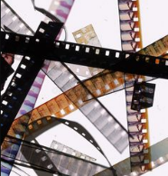

<https://i.pinimg.com/236x/d4/e2/aa/d4e2aa511f7f33055dfc0307c76847d0.jpg>

LITERATURA

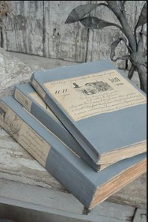<https://i.pinimg.com/236x/30/d7/dc/30d7dca5cc137f164dbc276aebcd8fb0.jpg>

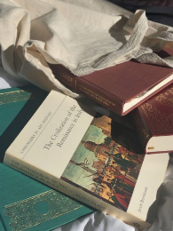<https://i.pinimg.com/236x/8c/f4/dc/8cf4dcd8be70c8b4f1b9f1fc8c323845.jpg>

<https://i.pinimg.com/564x/79/a0/18/79a018f4845280c724d8da7e3cf31c4b.jpg>

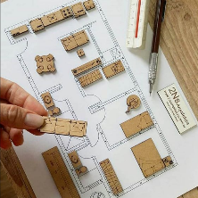ARQUITECTURA

<https://i.pinimg.com/564x/b1/19/8d/b1198d42d96da3ea911dd46e7d4aaa2d.jpg>

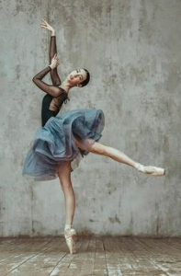DANZA

<https://i.pinimg.com/236x/67/8b/63/678b6374ed3dad723b76cc9496026a38.jpg>

<https://i.pinimg.com/236x/6d/60/72/6d60727ceb6a77c81ccaa6a6c0d2b591.jpg>